Step 1: assign the tag a name

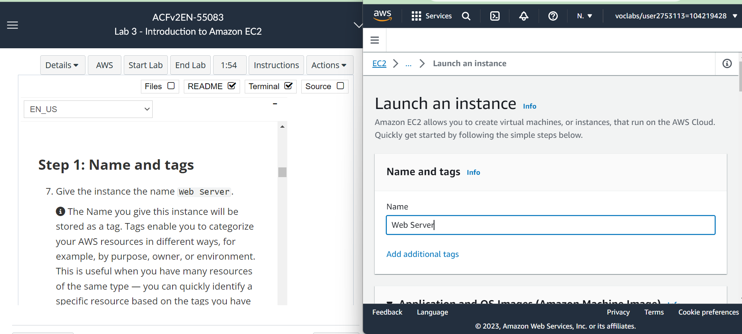

Step 2: Choosing AMI – a template to create the EC2 instance

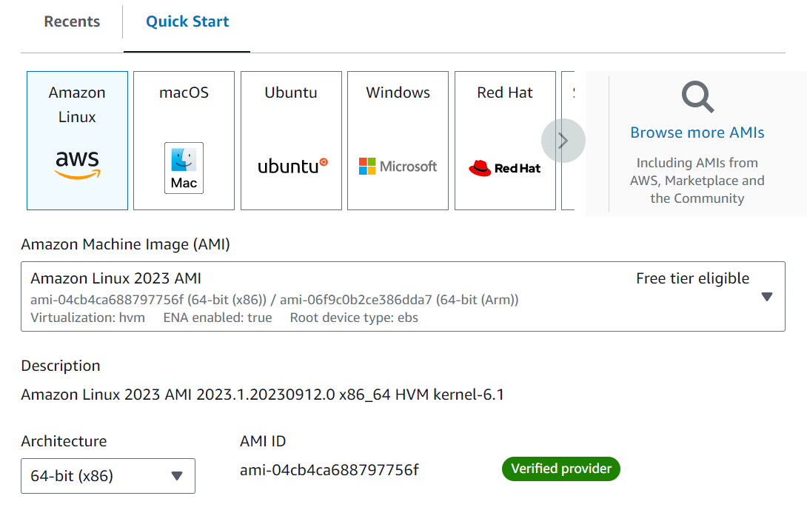

Step 3: Choose the spec of our EC2 instance, in these case t2.micro as instructed

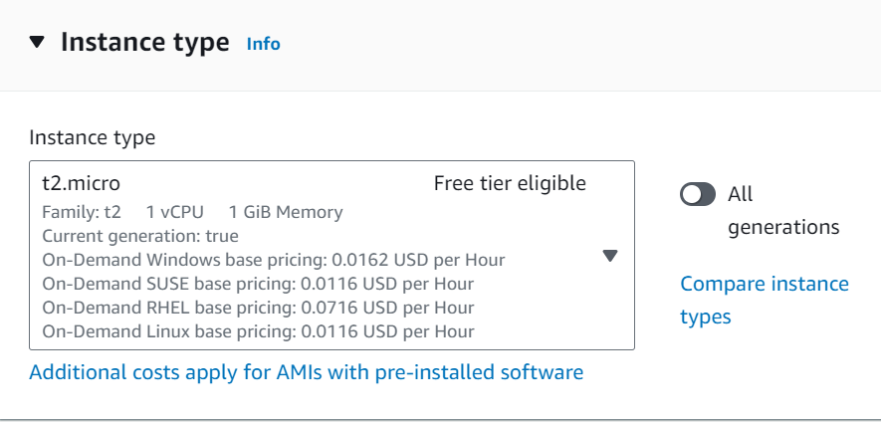

Step 4: Choosing Key pair – a password to access our EC2 instance

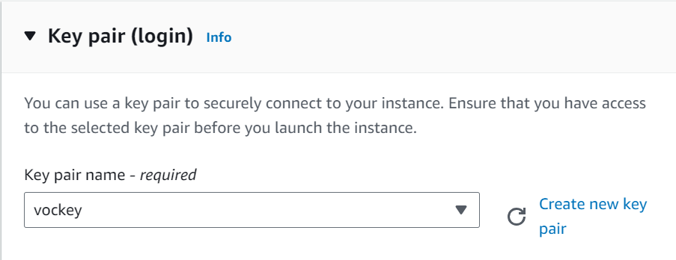

Step 5: Choose the network configuration

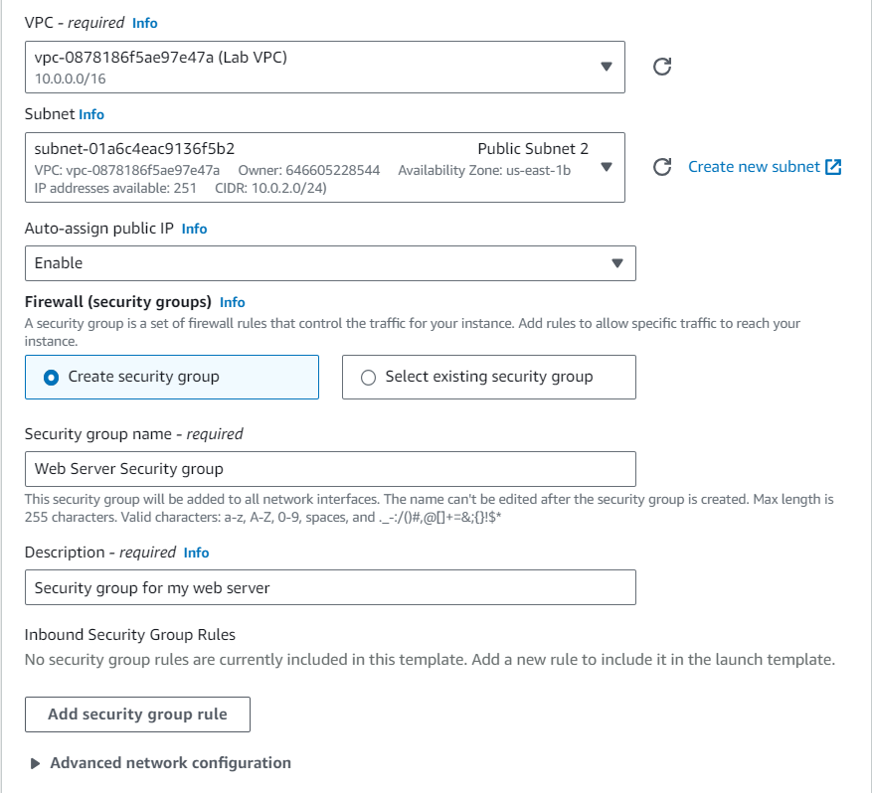

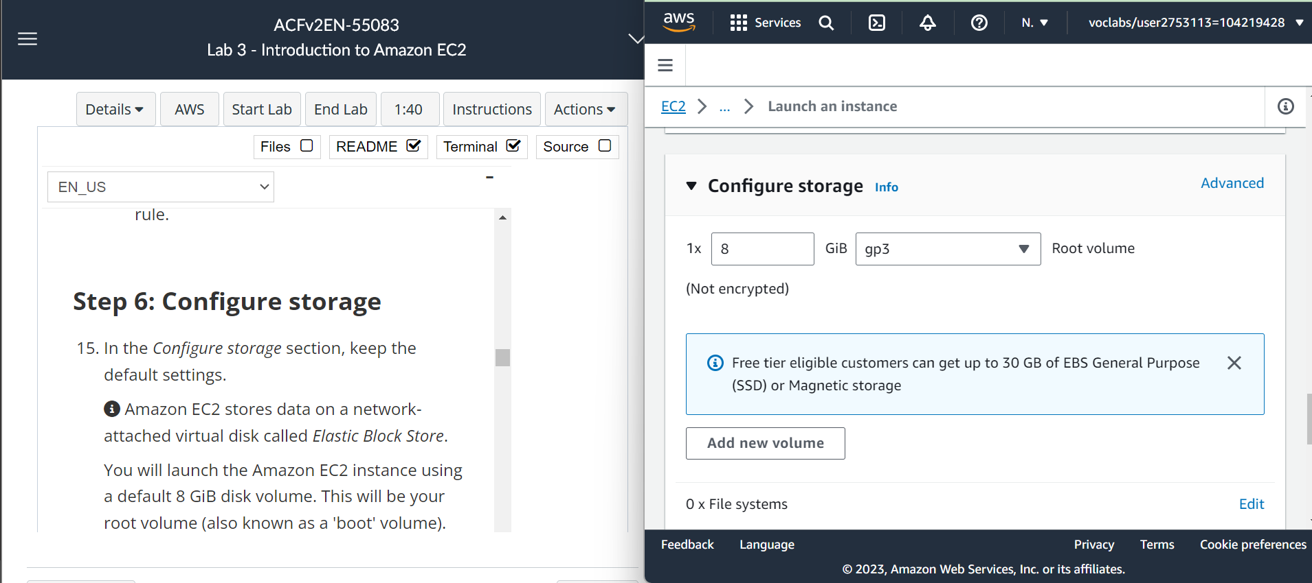Step 6: Choose the size of the storage

Step 7: Turn on termination protection so accidental termination don’t happen and install a hello word program

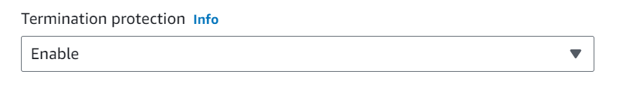

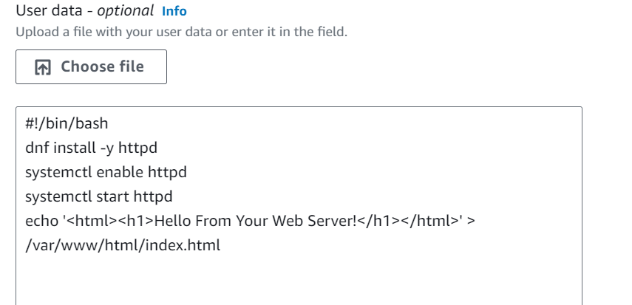

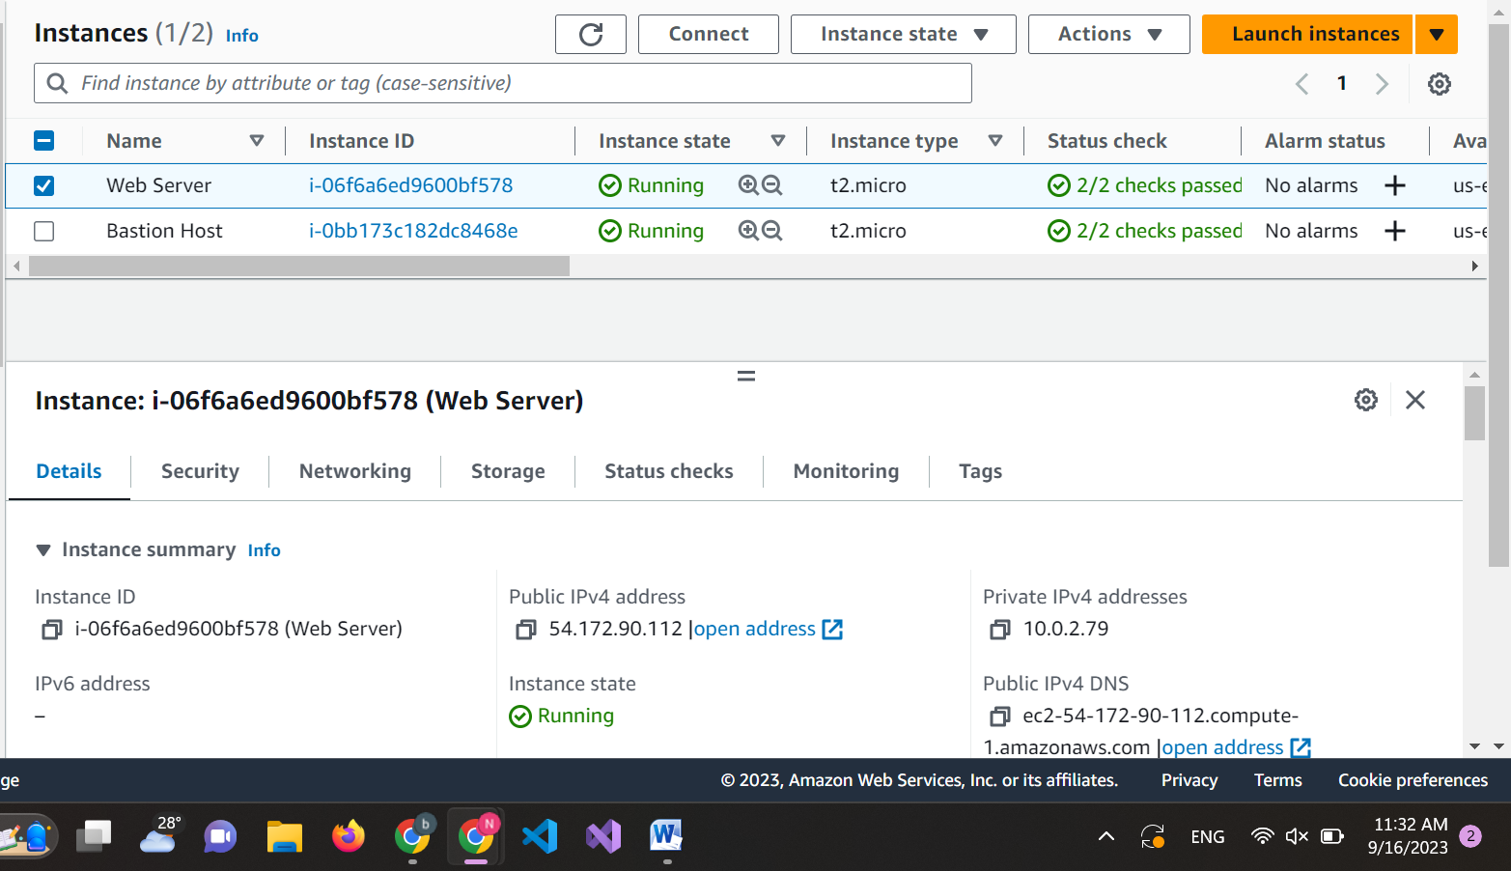Step 8: Launch instance name “Web server” successfully

Step 9: View system log

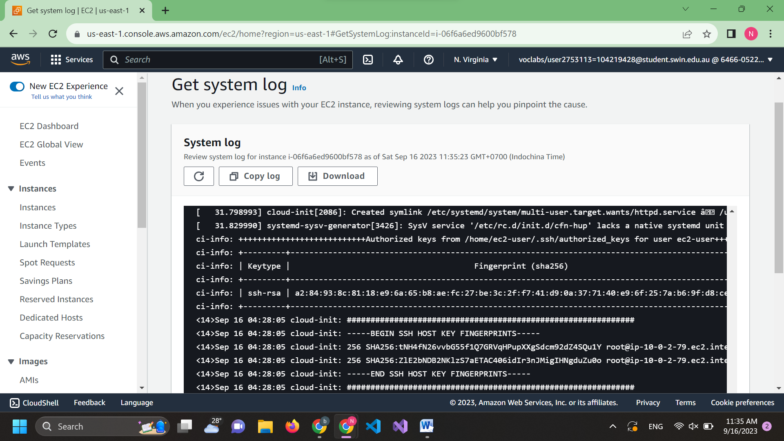

Step 10: Instance screenshot

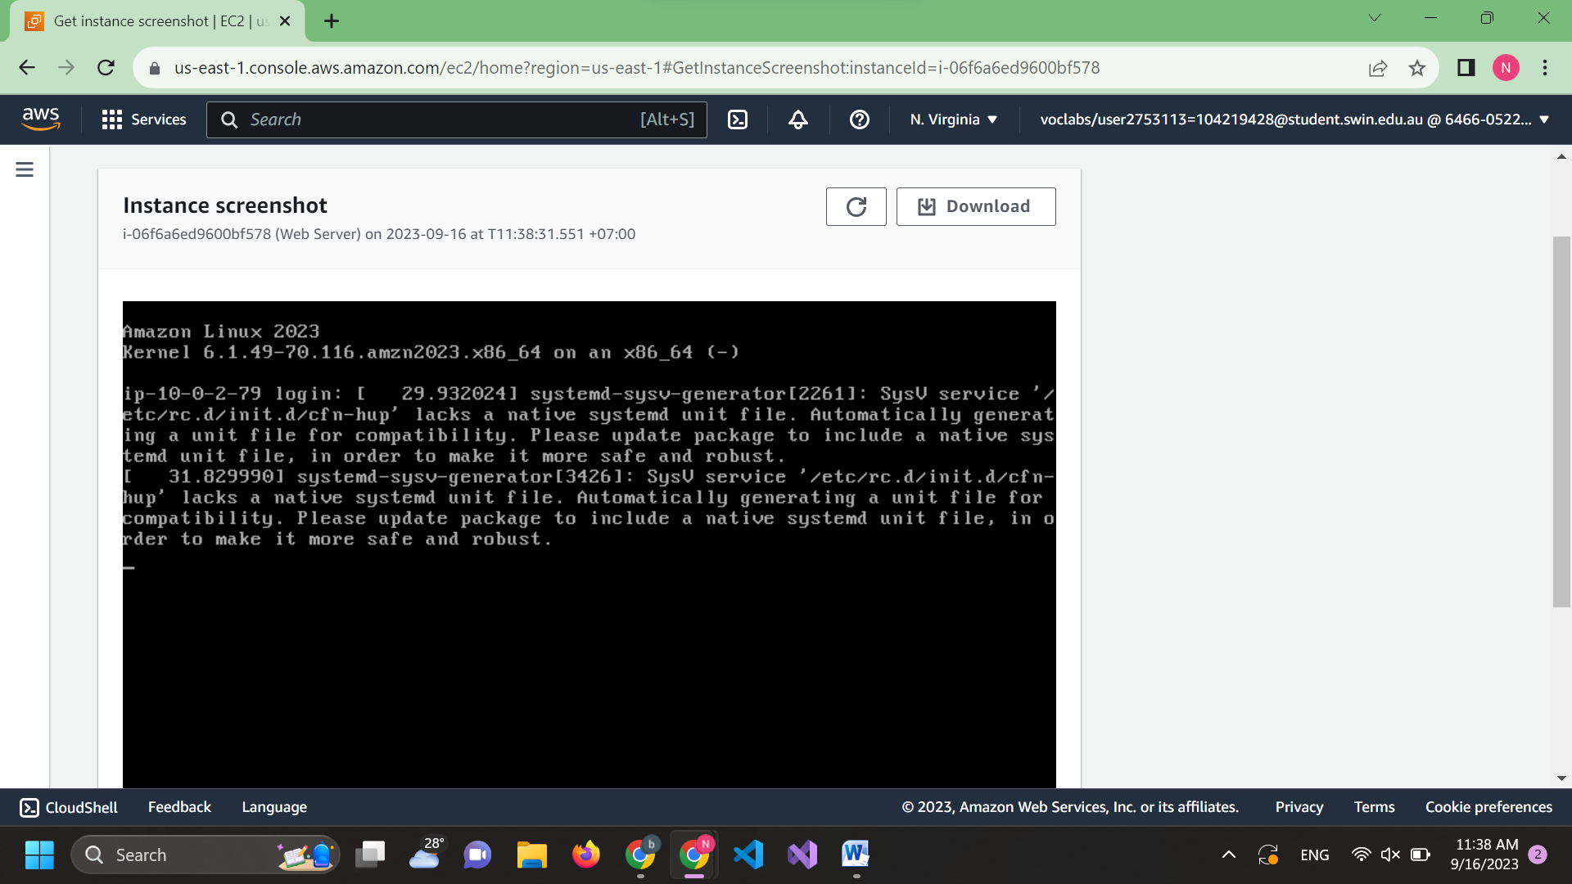

Step 11: Configure security rule

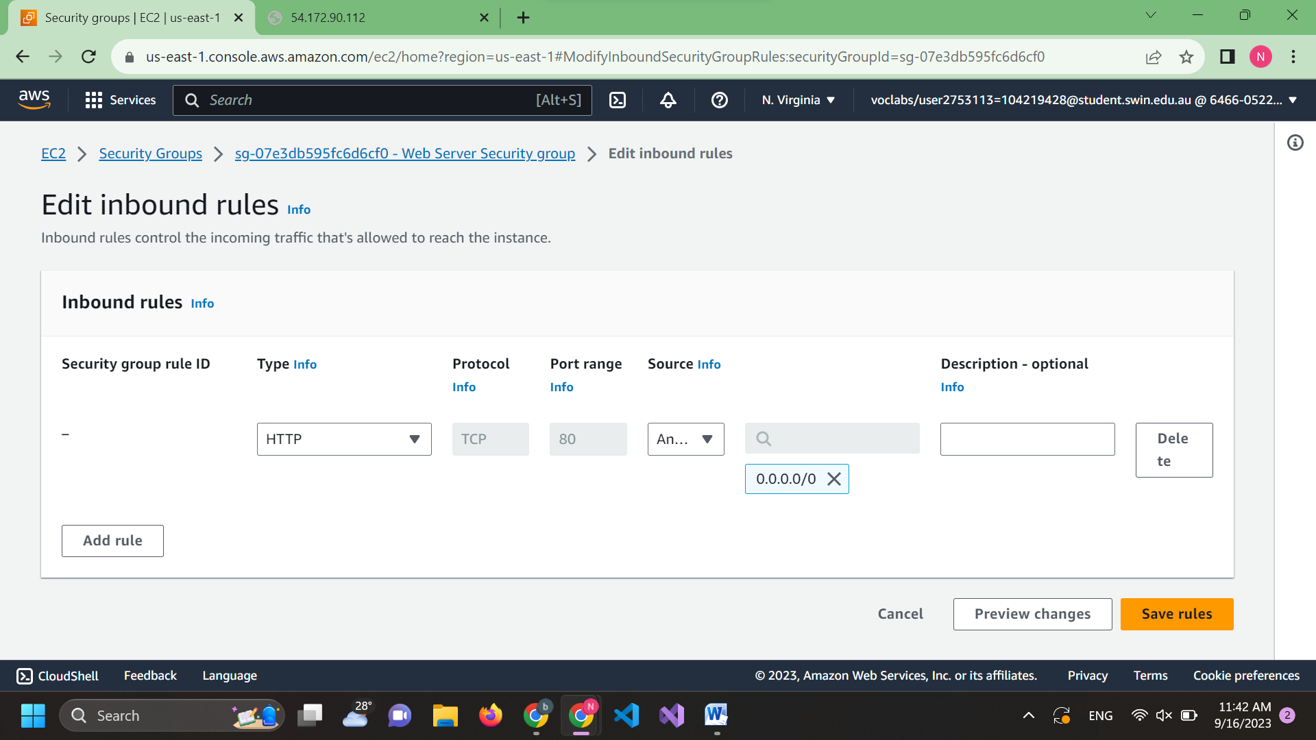

Step 12: Successfully update security rule to access web server

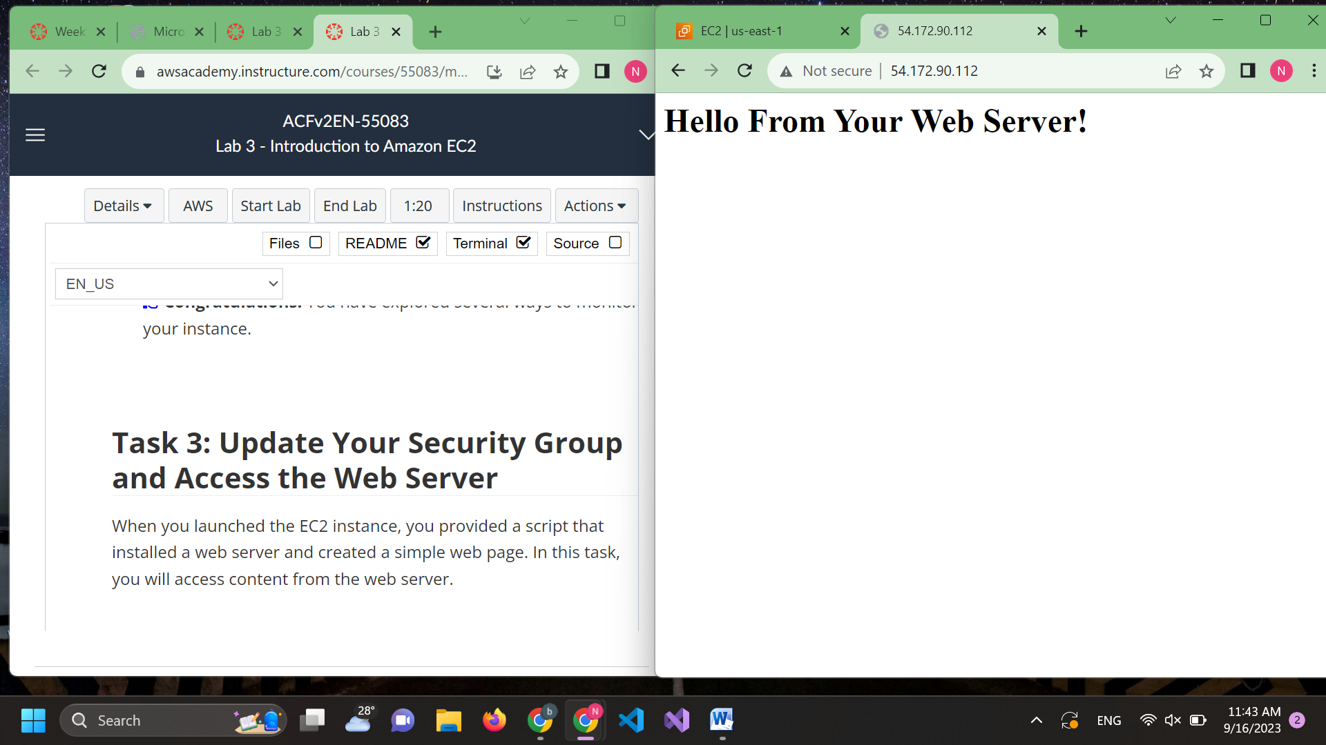

Step 13: Testing stop instance

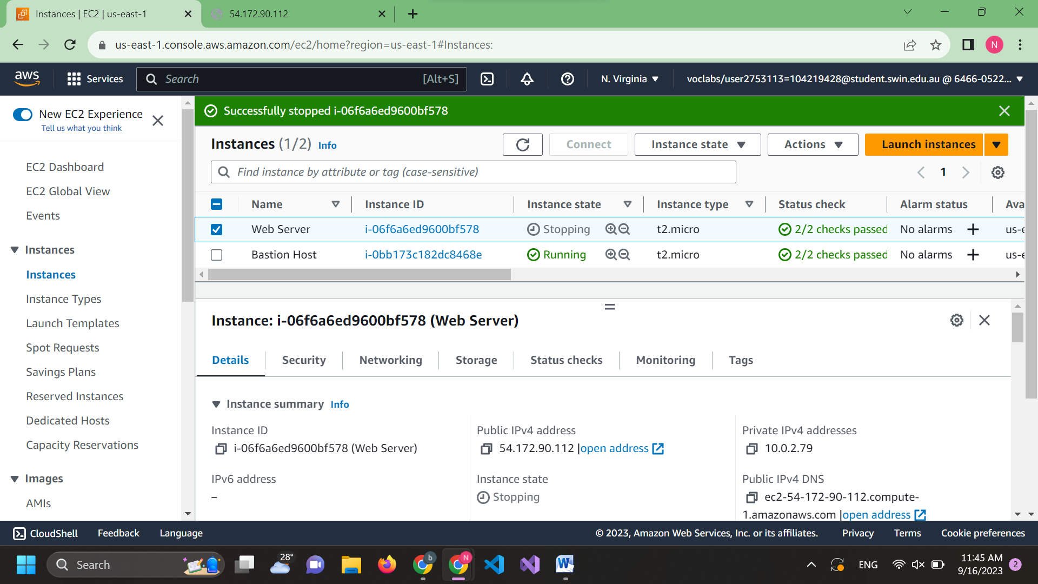

Step 14: Change instance type

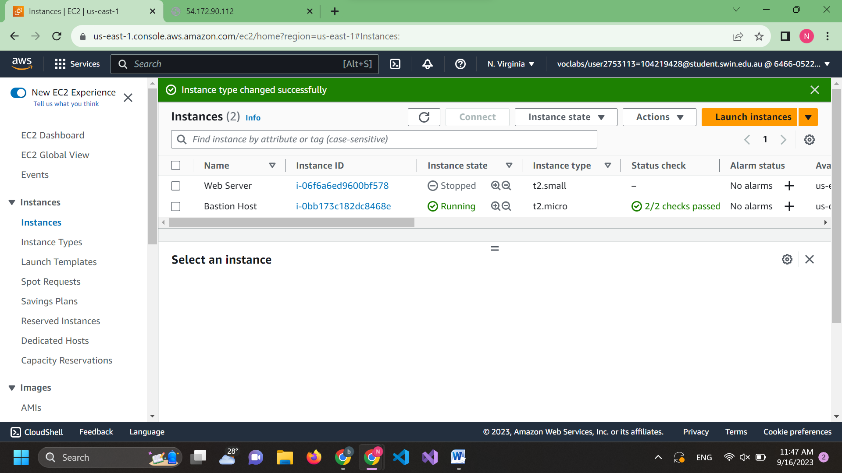

Step 15: Change disk size

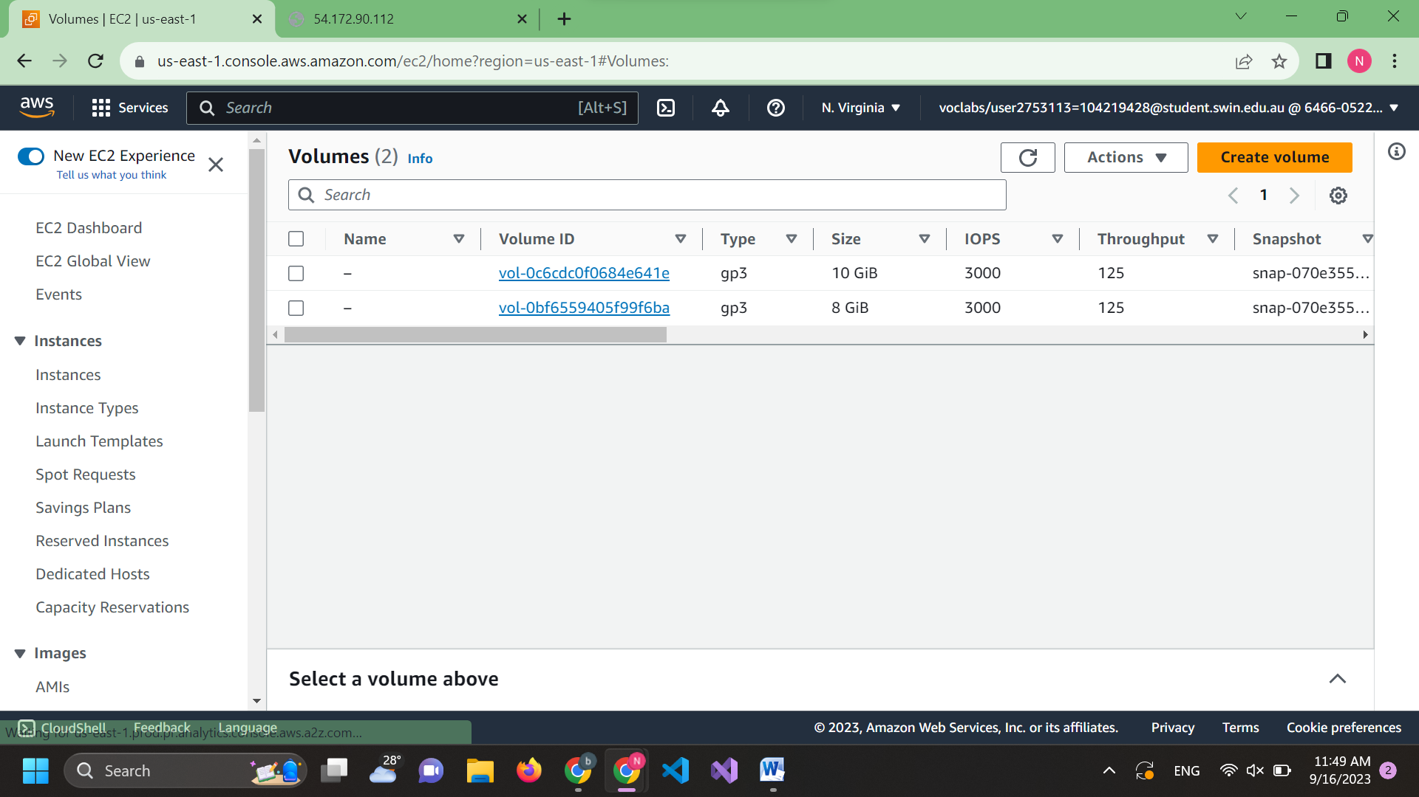

Step 16: Start instance again

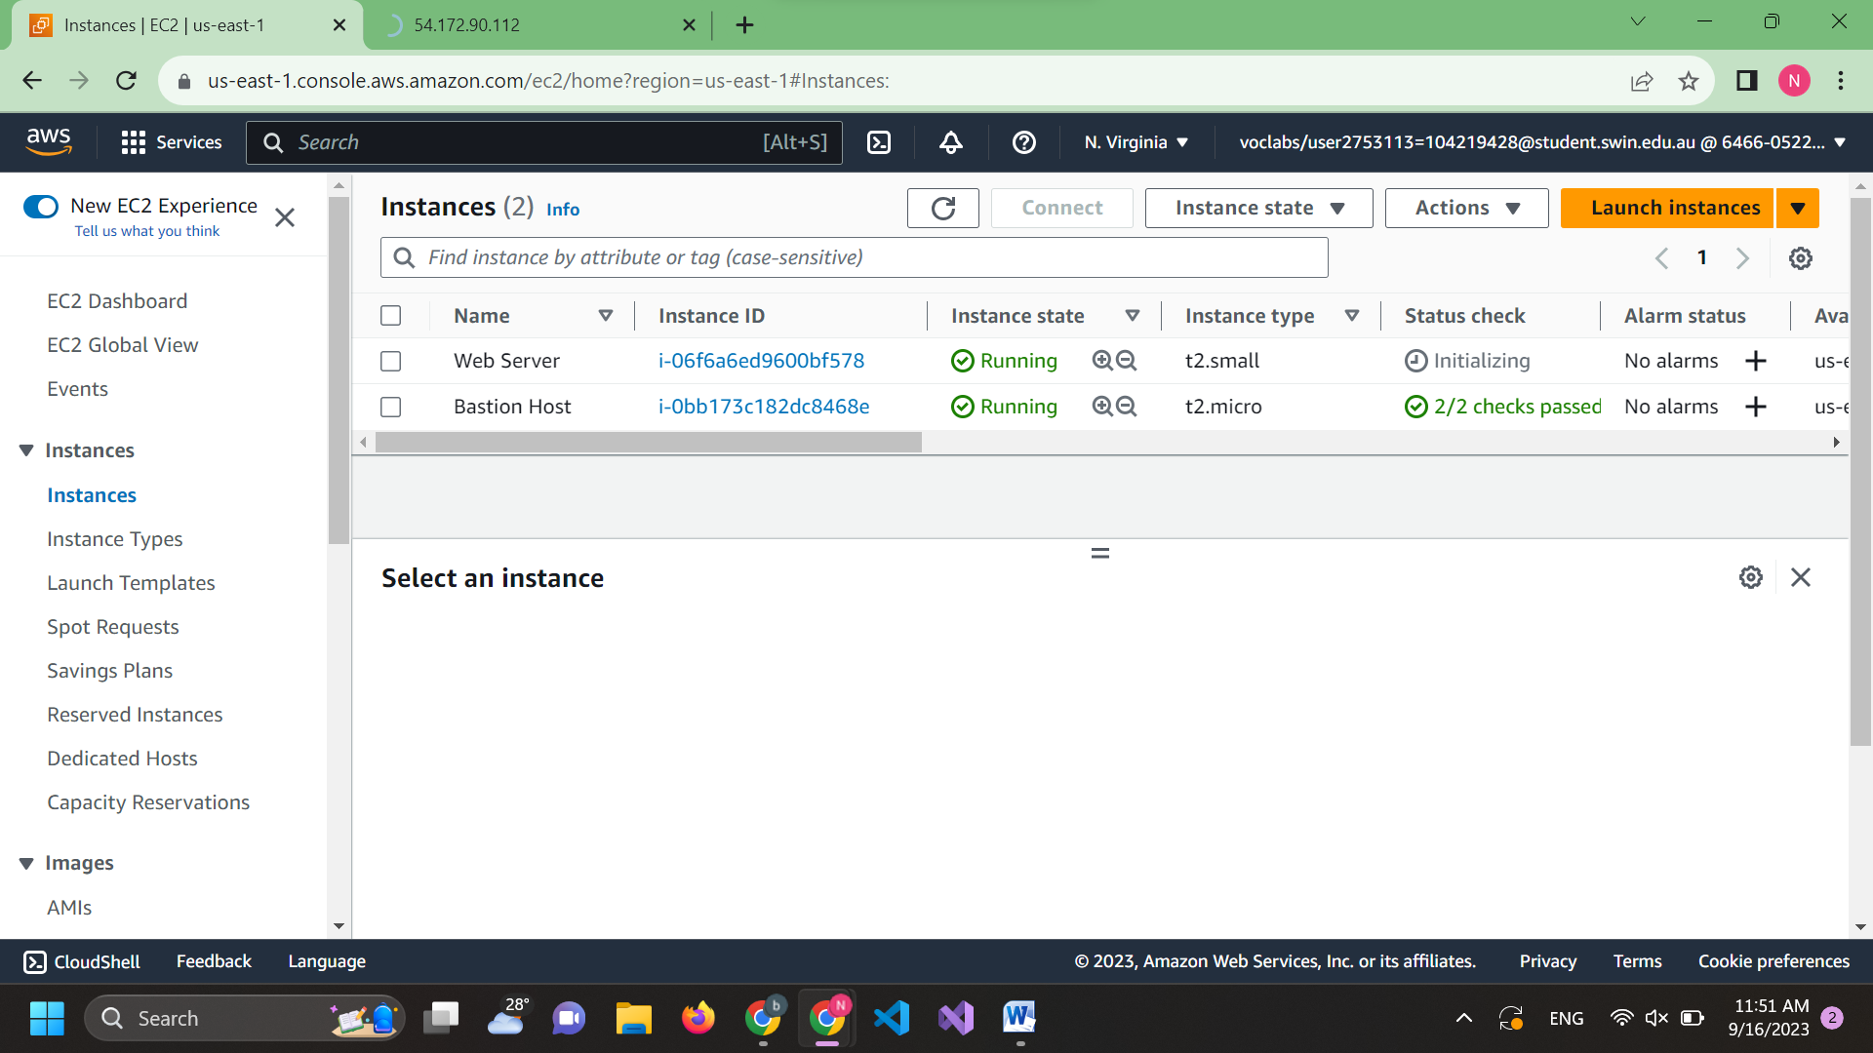

Step 17: Check termination protection

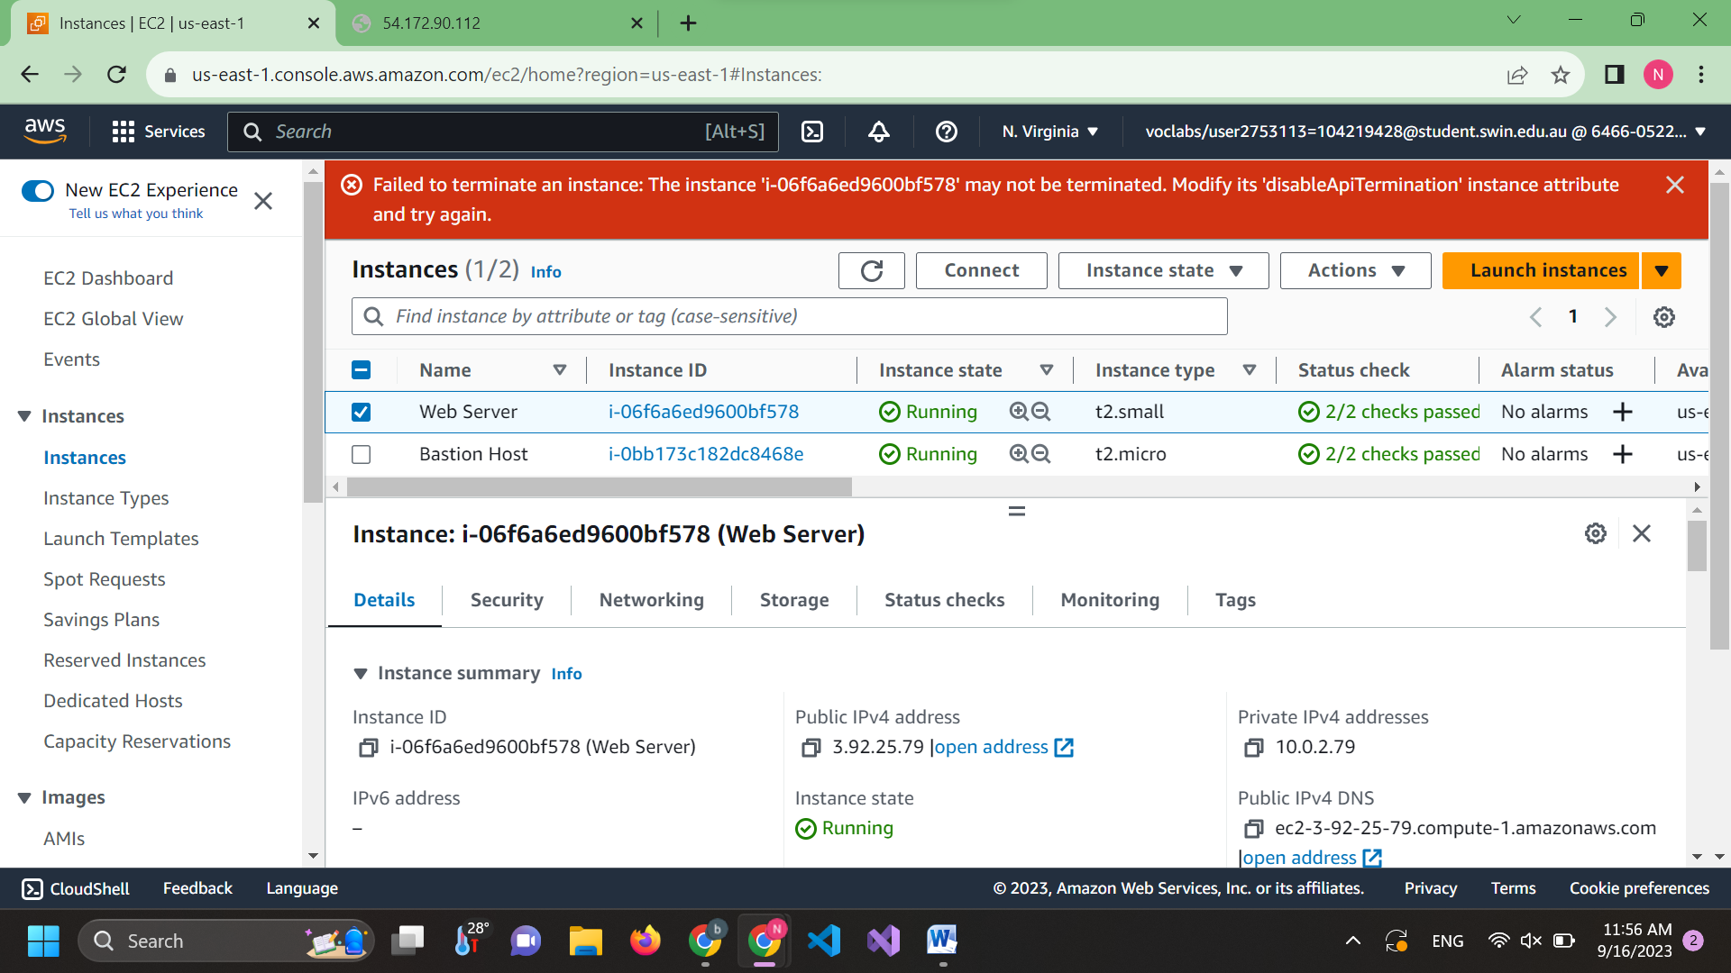

Step 18: Terminated instance successfully after removing termination protection

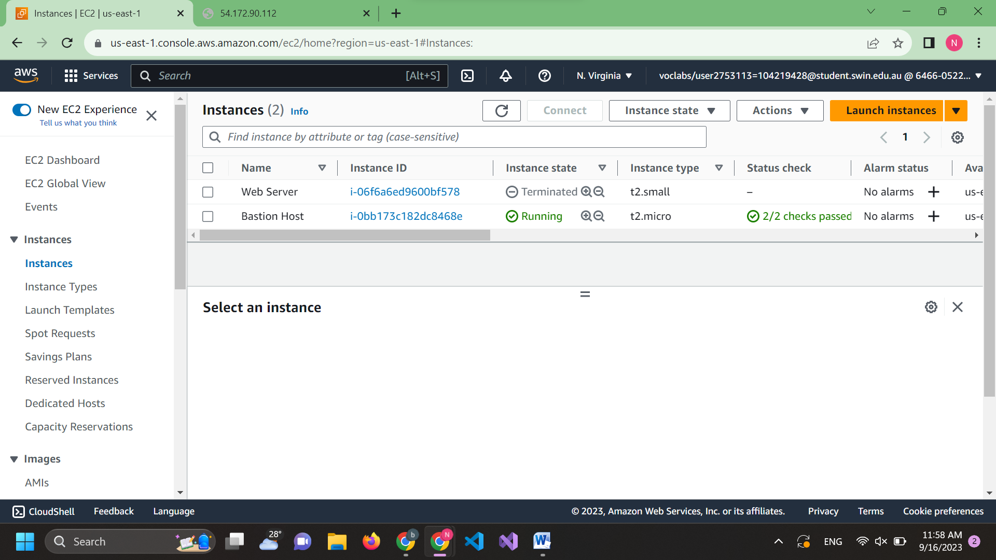

Step 19: End the lab

